



Headline : GAIN, Alltech and Showjumping Ireland Back New Autumn Grand Prix Series
Subheading: GAIN Equine Nutrition Launches New Autumn Grand Prix Series in Partnership with Alltech and Showjumping Ireland.
GAIN Equine Nutrition, in collaboration with Alltech and Showjumping Ireland, is proud to launch the Autumn Grand Prix Series, a dynamic new initiative set to energise the Irish show jumping calendar this autumn.
Spanning six premier equestrian venues across the country, the series will run as a seven-part competition, featuring both 1.40m Grand Prix Classes and a 1.20m Series Class, with events taking place in both indoor and outdoor arenas.
This initiative represents a significant investment in the sport, with a guaranteed minimum prize fund of €6,000 per leg. Each Grand Prix (1.40m) will carry a €4,000 prize pool, while the 1.20m Series Class will offer €2,000 in prize money, aimed at attracting both elite competitors and emerging talent.
Philip Gilligan, Country Manager for GAIN Equine Nutrition in Ireland, expressed his enthusiasm for the new series:
“We are delighted to partner with Alltech and Showjumping Ireland on the Autumn Grand Prix Series. This new initiative underlines our shared commitment to supporting Irish show jumping, particularly at a time when riders and venues alike are working hard to extend the season and provide more opportunities for competition. By investing in both the Grand Prix and 1.20m Series Classes, we hope to create a platform that benefits professionals and aspiring riders alike, while strengthening the calendar for the sport.”
Sarah Maher, Regional Manager Alltech Ireland, spoke of her excitement for the new series:
“Alltech has worked with GAIN Equine Nutrition and Show Jumping Ireland over the past number of years to support Irish show jumping. The launch of the new Autumn Grand Prix Series marks a very exciting development in our long-standing relationship. This series is designed to give Irish riders an outlet to compete at a high level during the Autumn months.
At Alltech, we have long championed the importance of adequate preparation and nutrition in achieving peak performance for high-performance horses. We are delighted to contribute to this goal through the Alltech additives featured in the GAIN Equine Nutrition feed portfolio, and now also through this new Autumn Grand Prix Series, an event we are confident will be competitive, thrilling, and highly rewarding.”
Open to riders from across Ireland, the Autumn Grand Prix Series aims to highlight the best of Irish show jumping talent while nurturing the next generation of competitors.

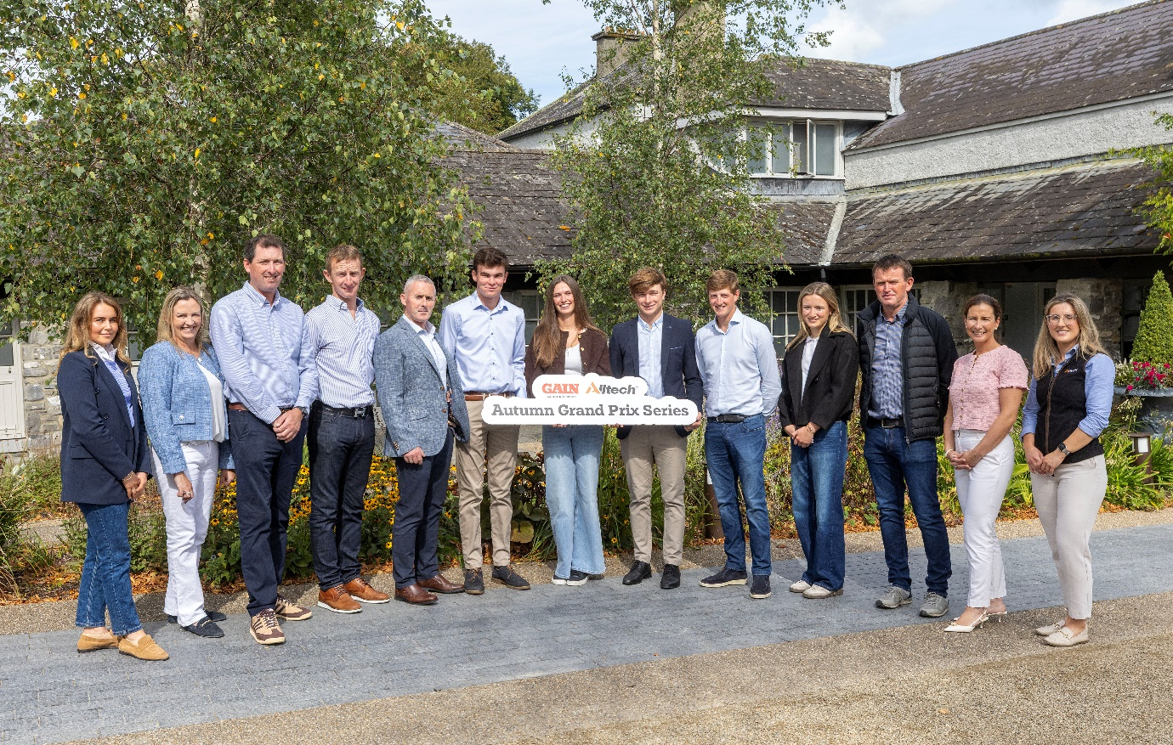
Pictured at the Autumn Grand Prix Series launch are, from left to right, Anna Smith and Marguerite Ryan of SJI, Kilian Browne of Sceilig Equestrian, Paddy O’Donnell, GAIN Equine Nutrition’s Philip Gilligan, Timmy Brennan, Susan Fitzpatrick, Seamus Hughes Kennedy, Jack Ryan, Emily Moloney, Eddie Moloney, GAIN Equine Nutrition’s Joanne Hurley and Rachel Gallagher of Alltech.
Showjumping Ireland Chair of Management and Finance Committee, Ronan Corrigan, welcomed the continuation of the organisation’s partnership with GAIN Equine Nutrition and Alltech for the Autumn Series, highlighting the importance of sustained support for the sport throughout the year. Speaking on the launch, he said:
"Showjumping Ireland are delighted to be able to continue their partnership with GAIN and Alltech through sponsorship of the Autumn Series. The purpose of developing this series at this time of the year is to ensure support and activity is ongoing through the autumn and winter. This is extremely important to the shows, venues, riders, owners and breeders who now have a well-funded series to follow across two height categories 1.20m and 1.40m which will encourage and assist all stakeholders during what might previously have been a quiet time within the sector.
We look forward to visiting new venues throughout the country and hope that this series will be of significant benefit to the sport and sector and we again thank GAIN Equine Nutrition and Alltech for continuing their valuable support to the sport and sector."
Open to riders from across Ireland, the Autumn Grand Prix Series aims to highlight the best of Irish show jumping talent while nurturing the next generation of competitors
Competition Dates
- Glenamaddy Equestrian Centre – 11th September (1.40m & 1.20m)
- Cavan Equestrian Centre – 11th October (1.20m)
- Garranemore Equestrian Centre – 18th October (1.40m & 1.20m)
- Sceilig Equestrian – 25th October (1.40m & 1.20m)
- Wexford Equestrian Centre – 1st November (1.40m & 1.20m)
- Cavan Equestrian Centre – 9th November (1.40m)
- Emerald Equestrian – 30th November (1.40m & 1.20m)

For more information contact:
Lisa Dunphy, Tirlán Senior Marketing Manager lisdunphy@tirlan.ie, 083 182 3337

